Project phase-II Technology architecture:

|  |  |
| --- | --- |
| **Date** | 11 November 2022 |
| **Team ID** | PNT2022TMID50773 |
| **Project Name** | Deep Learning Fundus Image Analysis for Early  Detection of Diabetic Retinopathy |
| **Maximum Marks** | 4 Marks |

# Technical Architecture:

1. The Deliverable shall include the architectural diagram as below and the information as per the table1 &

table 2.

1. It could explain the basic components and the technical solution for it to solve by the technical

architecture..

3. It involves the development of a technical blueprint with regard to the arrangement, interaction,

and interdependence of all elements so that system-relevant requirements are met.

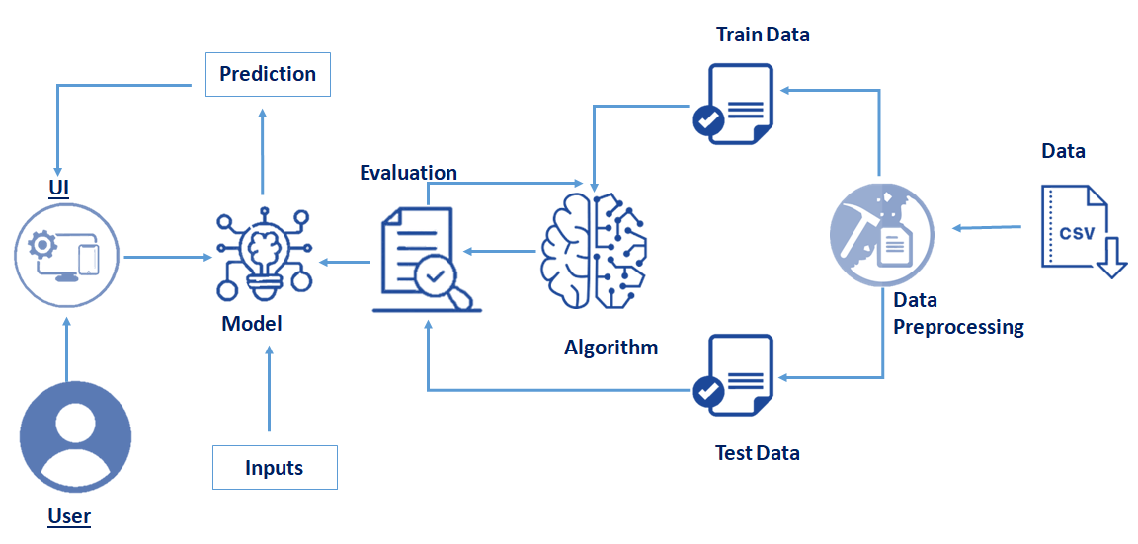

# 

**Table:1 Components & Technologies**:

|  |  |  |  |
| --- | --- | --- | --- |
| **S.No** | **Component** | **Description** | **Technology** |
| 1. | User Interface | How user interacts with application e.g. Web UI etc., | CSS, JavaScript, |
| 2. | Application Logics | Logic for each and every process in the application | Python, JavaScript. |
| 3. | Cloud database | Database service on cloud | IBM Cloudant. |
| 4. | API | Used to call the functions in order to access the execution in another framework | Python Flask , NodeJS (if needed). |
| 5. | Deep Learning Model | The model is developed to predict the rainfall using  ML algorithms | Sklearn, DL Algorithms. |
| 6. | Data Pre-processing and Analysis | The available data is formatted or converted into the format which will be suitable for the ML model | Matplotlib, Tensorflow, opencv. |
| 7. | External API | API to fetch FUNDUS Image from Kaggle | Google’s Kaggle API |

**Table:2 Application Characteristics:**

|  |  |  |  |
| --- | --- | --- | --- |
| **S.No** | **Characteristics** | **Description** | **Technology** |
| 1. | Open-Source Frameworks | Backend Framework, Non-structured Database. | Python Flask / NodesJS, IBM Cloudant. |
| 2. | Security Implementations | Email Verification and authentication using JSON object by comparing the data exists in database. | Encryptions, Direct verification using Backend Framework. |
| 3. | Scalable Architecture | To ensure that enough resource is allocated on the hosting platform to keep up with demand | IBM Cloud Kubernetes Service. |
| 4. | Availability | The website will be made available by hosting it in cloud hosting platforms | IBM cloud hosting. |
| 5. | Performance | Multiple prediction requests should be handled simultaneously without affecting the speed and  accuracy of prediction | Load Balancers and Distributed servers. |